# Information Regarding Chocolate 3D Printer

MMKF10 MMKF40

Robert Danielsson

Robin Bergman

Tristan Moffett

Kristoffer Palmér

# 

# Assignment

The following work is part of the course MMKF10 and MMKF40, where the primary goal was to build a chocolate 3d printer using water as coolant and support.

This project is a continuation of a former student project which came up with the basic idea.

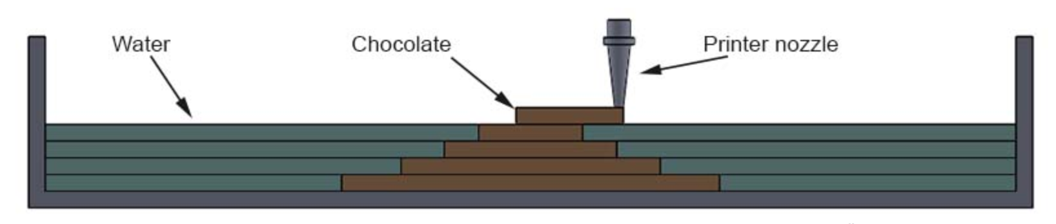

# Parts

|  |
| --- |
| 101 Hero 3D printer |
| SLS 3D printed extruding head |
| Relay board |
| Arduino Uno |
| Peristaltic pump |
| Wires |
| Tank unit for bottom plate |
| Laser cut tower for extruder |
| Syringe |
| 3D printed part for plunger and step motor connection |
| CNC machined part for base of printing tank |

# Function

The printer is controlled by a computer, where the software Cura is used to send the print to the printer. The extruder head that comes with the 101Hero has been disassembled, and the step motor inside the extruder head is disconnected. The heating unit and fan is still connected so that the software can detect them and will run. The step motor is replaced with a Wantai 39BYGL215A. There is a picture included in the compressed folder that shows the wiring layout.  
For the water level controller, an Arduino Uno is programmed to receive an input signal from two wires that are in contact with the water. One wire is at the bottom of the printing tank, and the other is attached to the printer nozzle. When both wires are in contact with the water, the circuit is closed and the Arduino is programmed to NOT send an output signal. When the printer head raises one increment, the wire which is attached to the head is raised out from the water and the circuit is broken. When this occurs, the Arduino sends an output signal to a relay board that runs the pumps.   
Chocolate is fed through a syringe mounted in a tower on top of the printer. The syringe plunger is attached to the stepper motors threaded rod with a custom made 3D printed part. A silicone tube is attached to the syringe and the extruder head, where chocolate is fed through.

# How to Print

The desired stl-file to print is uploaded to Cura. The settings used are seen below.  
  
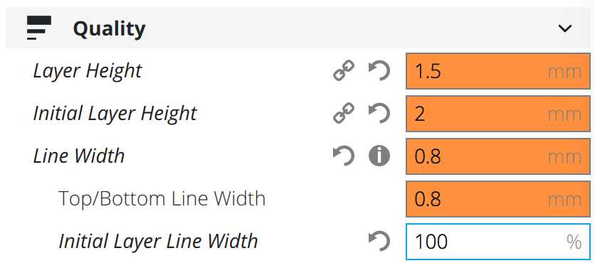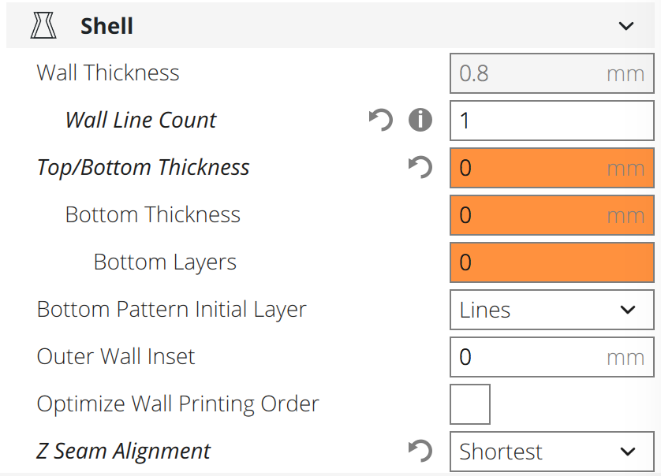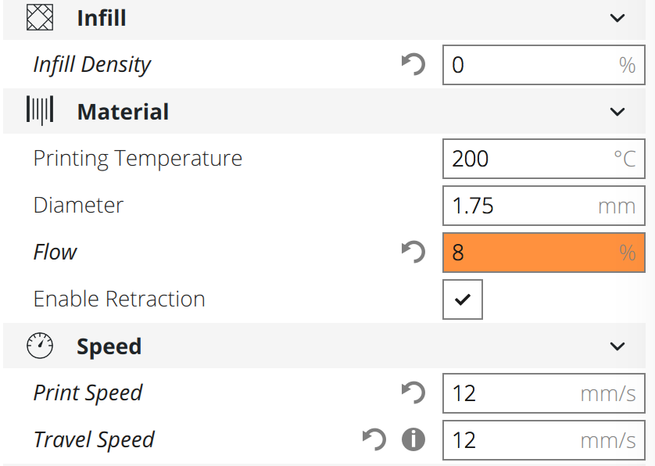

The temperature needs to be set to 185 degrees celsius for the printer to print.   
To load the syringe with chocolate, the chocolate is melted in a separate container, and then manually sucked up into the syringe. The syringe is then screwed into the motor, and placed into the extrusion tower on top of the printer. Finally, the tube connecting the syringe and the nozzle is connected, and some initial chocolate is extruded in order to fill the tube and nozzle before printing begins. When the syringe has been filled with chocolate, the tower has to be held down by hand so that the plunger is pushed into the syringe by the step motor when printing.

In order to get a good print the settings needs to be on point in Cura. It takes some know how and time to set everything up right because chocolate differs very much from plastic when it comes to material properties.

# Problems

# With the existing water pumps, even running at full speed with no stops, manual addition of water is required during print to keep the water at the right level. The component measuring whether or not the water is level with the print head is at this moment not very reliable. Making the pin too long makes it hit the walls of the water tank while printing and a too short pin might touch the printed chocolate.

Another problem with the water system is getting water inside of the print. If a print has closed off portions it will keep the water out and without the support of the water from the inside the pressure differences and differences in how fast the chocolate is hardening might cause portions of the print to fall inwards. Our solution to this problem was to manually add water to the inside of the print. 1-2 people used syringes of water to slowly add cold water to the inside of the print, throughout the printing process.

One problem with the printing process was the force needed to push the chocolate out of the syringe. The motor was strong enough to do it, but it required that one person hold down the extrusion tower on top of the printer. If it was not held down, then the tower would be pushed up by the force of the motor, instead of the syringe plunger being pushed down. If the chocolate was not at the correct temperature, or not the correct type of chocolate, then the syringe would not extrude at all, because the motor could not push hard enough, or the person holding the tower could not push hard enough.

The type of chocolate used was another problem, and how long it was heated for. We found that certain types of chocolate work much better than others. Some chocolate was too hard for the syringe to extrude, and sometimes it was not melted enough. Re-melted chocolate became much harder and less liquid and was not usable. Milk chocolate works better than dark chocolate. Finally, the chocolate could not be heated with water that was too hot, as it can easily burn and solidify if left unattended. One of the attached pictures shows the chocolate found to work the best. The near hottest water that comes from any sink is a good temperature to use to melt the chocolate, if replaced every 10 minutes or so.

These problems all result in a lot of time spent of preparation even though the actual printing is fast. It also requires a minimum of 2 people to operate the printer due to having to having to hold the extrusion tower and adding water manually. Ideally using the printer should only require one person who only needs to program the printer and do cleanup and refilling of chocolate and water.

Recommendations for Further Development

Towards the end of the project, especially during the final stages while trying to print as well as possible, several improvements to the printer were thought of that could not be realized because of time and budget restrictions.

Steps that could be taken to address the problems with the water system:

* Replacing the pumps with a stronger and more accurate pump
* Designing and creating a more stable and reliable water measuring component
* Increasing the size of the water tank in one direction so that the water measuring component has room to move without touching the walls of the tank or the chocolate
* Finding a way to get water to the inside of prints automatically. For example by:
  + Designing parts for printing that let water inside of them in the first layer of printing
  + Redesigning the water tank to let water inside the print through grooves or canals in the bottom plate.
  + Adding separate pump to fix this issue

Steps that could be taken to address the problems with the chocolate feeding system:

* Redesigning or stabilizing the extrusion tower
* Do further tests and research to figure out what chocolate at what temperature works best for printing
* Create a more accurate system for melting and loading chocolate to the syringe
* Consider using peristaltic pumps for chocolate extrusion instead of syringe